Lakshmi Narain College of Technology & Science, Bhopal

Department of Electronics and Communication Engineering

Name: Madhuri Darkar Enrolment no.:0157EC181048 Class: EC V D

Date: 25/08/20 Page no.: 01

**PRACTICAL-1**

Aim: Introduction to Scilab.

Software required: Scilab version 6.0.2

Theory:

Scilab is an open-source, cross-platform numerical computation package and high level, numerically oriented programming language. It can be used for signal processing, statistical analysis, image enhancement, fluid dynamic simulations, numerical optimisation and modelling and many more.

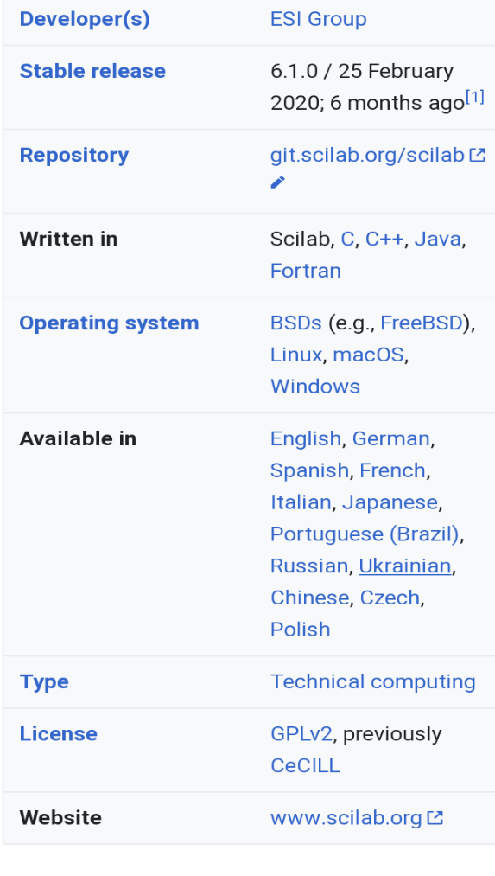

Lakshmi Narain College of Technology & Science, Bhopal

Department of Electronics and Communication Engineering

Name: Madhuri Darkar Enrolment no.:0157EC181048 Class: EC V D

Date: 25/08/20 Page no.: 02

Scilab was created in 1990 by researchers from INRIA and ENPC. It was initially named Ψlab. Scilab Enterprises was created in June 2010. It develops and markets a comprehensive set of services for Scilab users. It also develops and maintains Scilab software. In early 2017, Scilab Enterprises was acquired by virtual prototyping pioneer, ESI group.

Scilab provides an interpreted programming environment with matrices as the main data type. This allows users to rapidly construct models for a range of mathematical problems. Scilab is available free of cost under an open source license.

Scilab syntax is largely based on MATLAB language. The simplest way to execute Scilab code is to type it in at the prompt, ––>, in the graphical command window. In this way, Scilab can be used as an interactive mathematical shell.

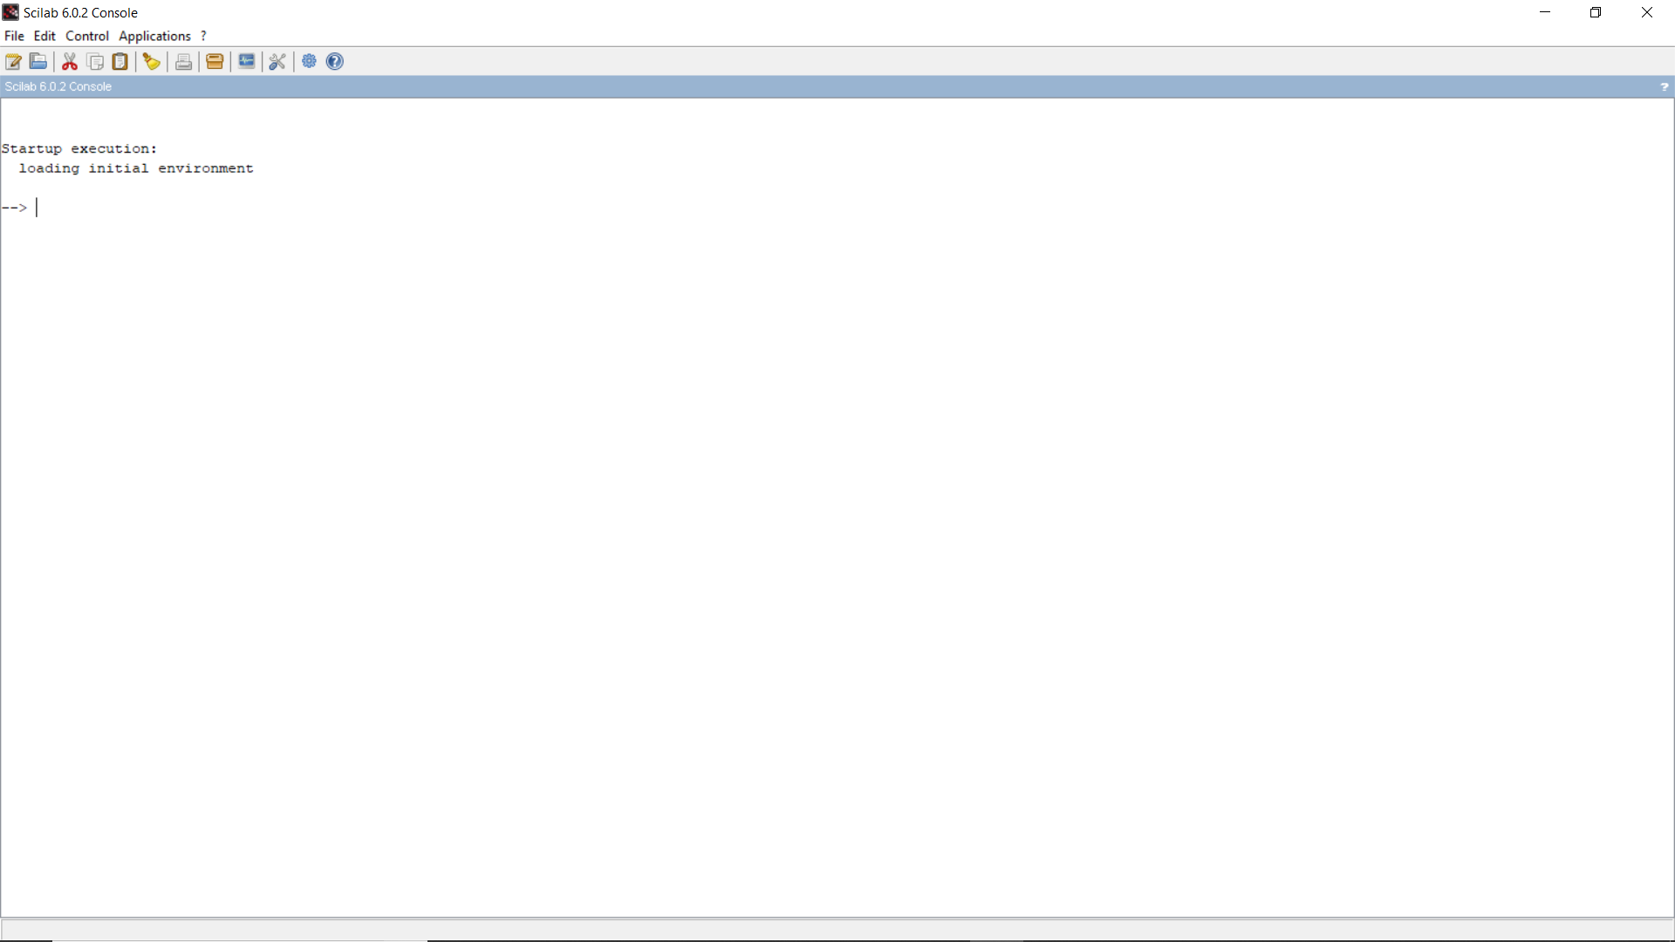

Lakshmi Narain College of Technology & Science, Bhopal

Department of Electronics and Communication Engineering

Name: Madhuri Darkar Enrolment no.:0157EC181048 Class: EC V D

Date: 25/08/20 Page no.: 03

The useful workspace in Scilab consists of several windows:

* Console for making calculations
* Editor for writing programs
* Graphics windows for displaying graphics
* Embedded help

Scilab environment by default consists of following docked windows- console, files and variables browsers, command history.

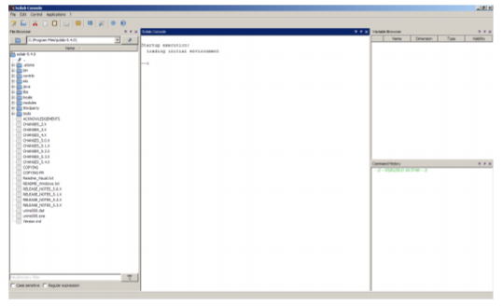

The menu bar:

*Applications*

* The command history allows you to find all the commands from previous sessions to the current sessions.
* The variable browser allows you to find all the variables previously used during the current session.

Lakshmi Narain College of Technology & Science, Bhopal

Department of Electronics and Communication Engineering

Name: MAdhuri Darkar Enrolment no.:0157EC81048 Class: EC V D

Date: 25/08/20 Page no.: 04

*Edit*

* Clicking on Clear Console clears the entire content of the console but the command history is still available and calculations done during the session are still in memory.

*Control*

* Type pause in program or click on Control>Interrupt in the menu bar if the program is already running. In all cases, the prompt, ––>, will turn into –1–>, then into –2–>, if the operation is repeated.
* To return to the time prior to the program interruption, type resume in the console or click on Control>Resume.
* To quit without any possibility of return, type abort in the console or click on Control>Abort.

The graphics windows:

A graphics window opens automatically when any graph is plotted. It is possible to plot curves, surfaces, sequence of points.

To obtain an example of plot, type in the console:

––>plot

Lakshmi Narain College of Technology & Science, Bhopal

Department of Electronics and Communication Engineering

Name: Madhuri Darkar Enrolment no.:0157EC181048 Class: EC V D

Date: 25/08/20 Page no.: 05

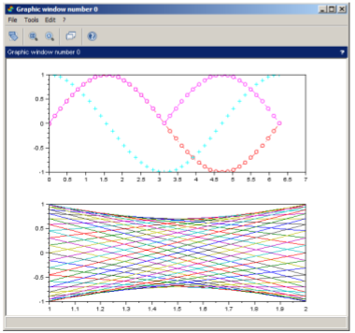

To access online help, click on ?>Scilab Help in the menu batype in the console:

––>help

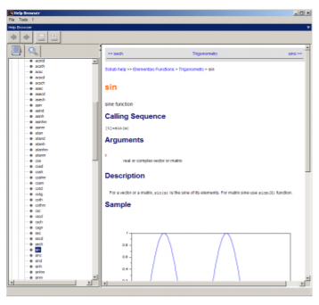

Lakshmi Narain College of Technology & Science, Bhopal

Department of Electronics and Communication Engineering

Name: Madhuri Darkar Enrolment no.:0157EC181048 Class: EC V D

Date: 25/08/20 Page no.: 06

To get help with any function, type help in the console followed by the appropriate function. For example:

––>help sin

displays sine function.

Teacher’s signature